Retail Sales Dashboard Explanation

- Top Categories By Total Price:

Below visualization in the dashboard has represents the total sales by each product category showcasing top 10 categories.

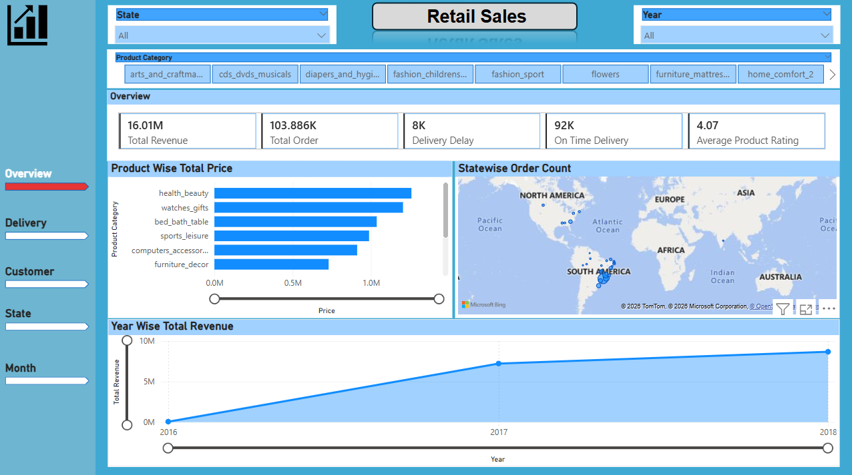

Gifting, furniture and beauty products are top contributors to the revenue.

- Delayed Order Analysis

Below visualization shows total number of orders delivered with number of delayed and on time orders:
Delivered Orders: 1,03,866K
Delayed Orders: 7827
On Time Orders: 91614

- MonthWise Comparison:
Below Visualization also shows month wise delayed and on time orders which can be further filtered:
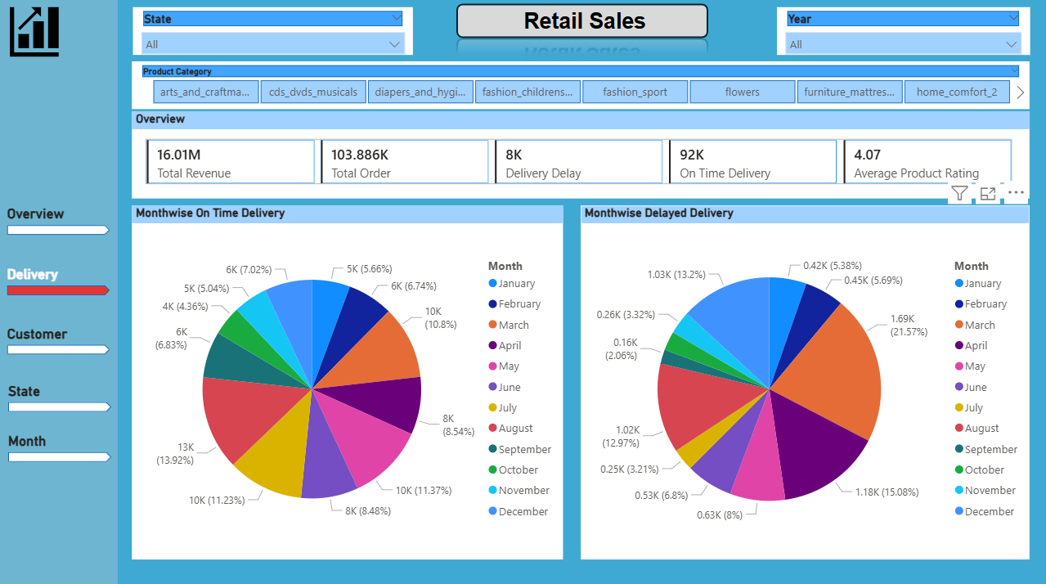

Analysis: There was a spike in delayed order in the month of March.

- Payment Method Analysis:
Below visualization shows the frequency of payment methods.
- Product Rating Analysis:
Below visualization shows the top 10 and bottom 10 products with customer ratings.
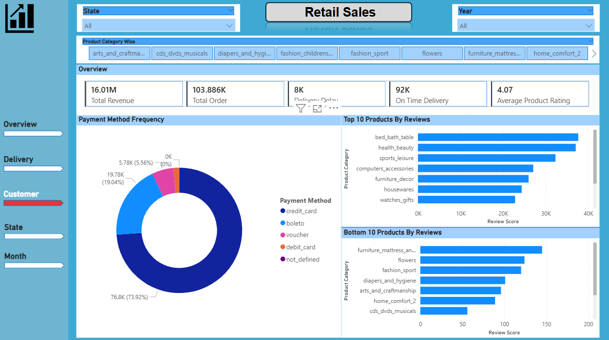
Analysis: Most frequently used payment method is Credit Card and most selling product category have the most review.

- State-Wise Sales Analysis:
Below visualization represents bifurcation of sales with State: With Sao Paolo having highest sales of 41667 orders and Roraima having lowest sales of 46 orders

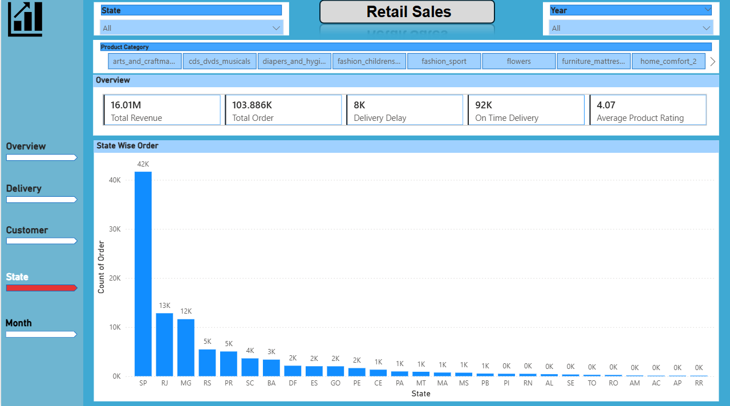

- Seasonal Sales Patterns:
Analysis says that we see a dip in sales in Quarter 3 and Quarter 4.
- However, the sales have increased from 2016 to 2018:
